Starts at: Halwa

Ends at: Vestige of Brass

**Important NPC’s:**

**al-Nassr Khatri:**

**Orim Sa’ri Haimii**: A suspicious drow elf. He has a skin black as night, and silver hair. He wears dark blue robes, complementing his skin, and beautiful crystal bracelets. A master of whispers, and collector of unusual artefacts. He will not disclose his information unless he gets something for it in return (mostly gold). He is hard to bargain with, but his artefacts are always real, just as the information he gathers.

**Efreet Pashah Nassirudeen Min Alnaar:** The cruel and greedy lord of the Vestige of Brass. He will not hear any word of dissonance, slander, whatever the hell. Only words of praise will enter his ears. He will only forgive people if they praise him, and end up striking a contract with him, of which he will of course get the better half of it.

**Shadow Caliph Batina Al-shaat** is the new Grandfather of the Loyalists.

**Other NPC’s:**

Haroun al-Saqr: Caretaker of the Oasis of the Golden Falcon: An imposing Janni female, dark skinned and with curly black hair. She is sassy and savage if needed.

Vestige of Brass city guards: The city is guarded by imposing figures, wearing robed pants, a turban covering their faces but their eyes, running barechested, showing their Golden sand skin. They are Jann (singular janni). They are employed, not through loyalty towards the Sultan, but through money.   
They are distant to the peculiars, scoffing them for being unenlightened.

***Locations:***

The oasis of the Golden Falcon: A large pond surrounded by a couple of buildings. Most notable of these is the Golden Falcon Inn, run by Haroun al-Saqr. There is a camel stable and some simple abodes. The Golden Falcon Inn is a square building with a large courtyard, with multiple doors leading inwards. There is one large hall, functioning as a dining hall and bar. This is where Haroun is found most of the time. She can be questioned about her race if players want to. She used to belong to the Jann of the Haunted Lands, until they ceased to be, after the disappearance of her Amir Heidar Qan. The rest of the Jann of the Haunted Lands claimed the southern side of the Haunted Swamps when it appeared. She sometimes meets another Janni from there, but they always bring tales of monsters in the Haunted Swamps.

***The Vestige of Brass:*** A city built inside an active volcano. The entrance is a large, beautifully carved hallway into the side of the volcano. The long straight hallway opens up into the crater of the volcano, showing a 3 tiered city, with a gate restricting entrance into the city, with a mote of lava surrounding the outer walls. There are buildings outside of the city, one of which is the Gate Inn.

The Gate Inn is one of the few buildings outside of the city gates. It is run by a fire genasi in red robes. He will not provide any information about what is going on inside the city, except that the night curfew provides him with guests. People caught on the streets during the night, or else they faced arrest, the loss of a hand, or even death.

The city itself is actually pretty empty for its size during the day, and especially during the night. There are some markets on the main streets, but it is noticeably more empty than other cities you have visited. The second tier is of-limits for people of poor standings, as is the case for the peculiars, it is here that most of the more … exotic market stalls are located.

Stores: general goods can be found on the market streets.

Magical Tattoo Parlor: A stall run by a Purple skinned Tiefling in blue robes, who goes by the name Wishama. She can transcribe magical tattoos onto peoples skins. She can offer some information on the workings of the Vestige if she may tattoo one of the players. She warns that the magic needs attunement, and the magic can disappear once not attuned anymore. If investigated, she has a tattoo of a crescent moon and a star.  
Tattoos: - Deserts kiss Tattoo: 100G-75G: A tattoo on the forehead, with swirling figures, as if symbolizing the desert winds. This tattoo gives permanent protection against the dangers of the deserts heat. In addition, once per day, you can use a reaction to gain resistance to any incoming fire damage.  
 - Illuminator’s Tattoo: 100G-75G: this tattoo contains beautiful calligraphy, taking up part of your writing hand. While this tattoo is on your skin, you can write with your fingertip as if it were an ink pen that never runs out of ink. As an action, you can touch a piece of writing up to one page in length, and speak a creature’s name. The writing becomes invisible to everyone other than you and the named creature for the next 24h. Either of you can dismiss the invisibility by touching the script. This action can’t be used again until the next dawn.   
 - Earth Fist tattoo: 250-200G : This tattoo depicts a hulking rock figure. While the tattoo is on your skin, your unarmed strikes are considered magical for the purpose of overcoming immunity and resistance to nonmagical attacks, and you gain a +1 bonus to any attack and damage rolls with unarmed strikes. **Earth’s fury**: As a bonus action, you can empower the tattoo for 1 minute. For the duration, each of your melee weapon attacks deals an additional D6 force damage, as your melee weapon attack picks up stone shards from the environment and launches it into the target. Once used, this bonus action can’t be used again until the next dawn.   
 - Blessing from the Enlightened Gods: 25G this tattoo is one of the Godly symbols. It is either slanted disc (Hajama, courage), tall waves (Hakiyah, truth), winds blowing(Haku, freedom), a thundercloud (Jisan, productivity), a sunburst (Kor, Wisdom), an arrow (Najm, adventure and the unknown), a crescent moon and a star (Selan, beauty), or a fountain (Zann, knowledge).  
In contrast to the other tattoos, these are only usable once.  
Gifted items: eyes of fire newts, Shadowstuff,

She will always give the characters an appropriate blessing, which is only revealed after she sets the tattoo, and she will explain the tattoos meaning:

|  |  |  |
| --- | --- | --- |
| Kor | Fountain | You can use your reaction to get advantage on an intelligence skill check or saving throw |
| Chuma | Sunburst | You can use your reaction to regain 1 level one spell slot |
| Shaya | Blowing winds | You can use your reaction to get advantage on a dexterity skill or saving throw |
| Sirona | Arrow | When used, your next attempt to a (long) rest will be fully guaranteed. |
| Thorion | Tall waves | You can use your reaction to get advantage on a wisdom check or saving throw |
| Luna | Moon and star | You can use your reaction to get advantage on charisma skills or saving throw |

She has other tattoo’s as well, but she is missing materials for them. The players can offer materials, and she will investigate them if she can use them for a tattoo. One of the usable materials is shadowstuff, which she will investigate in order to make a tattoo.

***Story:***

The peculiars will have to pass by the Temple of Kor again. They are granted the usual safe sleeping place. If they ask around, the priests will tell of the recovery of Rhundas, who is on his way back to the temple of Kor. He has asked to leave the p-eculiars with his Circlet. He says it always helped him against headaches, and it might prove useful against the creature they encountered in Bryyo. It grants resistance against psychic damage to the wearer. He writes that his notes in his study might prove useful for them.

The notes in Rhundas’ study tell you: The goddess of Bryyo was seen as an enemy of the Zakharan deities. The city was doomed by the Zakharan deities about 2000 years ago. The goddess revered in Bryyo was linked to the Shadowfell, a dark mirror of the World, as the Faewild is the light mirror of the World. Weirdly, much clearer documented, the city of Thultanthar and Netheril in Faêrun was transported to the Shadowfell around the same time, in an accident that almost destroyed the Magical Weave. The ruins have only recently started surfacing, about 5 months ago, as the sands around it have been slowly swept away by the winds. I’ve went up and down a couple of times, and I have seen them skulking away with empty hands. I am trying to find more than but shiny pebbles here and there. Not only the amount of information would be so precious, as their magical powers, I had found old Midani texts referencing a secret to cheat death! I have told only those I trust, but it is possible that other texts tell of the same tales of Bryyo, and in that case, it wouldn’t take too long until other more nefarious creatures get interested as well.

I have heard tales from the Jann of the Swamps, that shadow creatures have been seen in the Haunted Swamps. Could this be connected to the unburial of the ruins of Bryyo? My plan is to visit the Jann soon, and find out what is going on in the Swamps.

One of the other ethoists has been acting strangely. I worry that one of my fears is coming true. More nefarious creatures are enclosing us. I cannot prove anything surrounding him, but whatever has entranced him, is looking for more information. I must speed up my plans, and will leave tonight, and entrust high-ethoist Khatri with the key to my office, and to not let anyone in without my explicit consent.

The group can pass by the Oasis of the Golden Falcon and sleep there, for 1G/Person.   
Sleeping outside is ill advised, as sandstorms often travel the Great Anvil, and they wouldn’t want their sleep to be disturbed by one. During their night, a sandstorm indeed pelts the oasis, forcing anyone outside to go inside. The sandstorm is accompanied by a howling noise. In case they do decide to stay outside, the peculiars can hear skittering in the sands. If they do not go back to the inn, they will be confronted by multitudes of Thri-Keen, pointing their spears towards them, and pointing to their bags. It is extremely hard to see things through the sand and the dark together, and it sounds like more of them are around the camp. The creatures want the food they have in their bags. Attacking them will provoke the anger of the entire Thri-Keen tribe. They will start attacking, dragging their fallen friends out of battle, but eventually retreating after having raided their items.

The peculiars can leave the day after. It takes another 2 days of traveling towards the Vestige of Brass. The great anvil is extremely harsh. Everyone without fire resistance will be doing constitution saving throws (DC10) on both days. Everyone who fails, will gain a level of exhaustion, that cannot be reduced while travelling the desert. The group will have to sleep in the open desert on their second night, but if they spend any time looking for a better place to sleep than the extremely harsh and dried sands, they will find a tree in the distance, alone against the empty landscape of desert around them. If they travel to it, they find a small oasis, complete with a pool of clean, crisp water. The tree itself looks strange. It is mostly dead and brown, topped with a single vibrant burgundy flower on top. There are many vines hanging off of it, their shaggy bark the texture of flaking skin. A DC14 Investigation check reveals that the sands around the tree cover an immense amount of bones from all manner of creatures. <https://www.reddit.com/r/DungeonsAndDragons/comments/gm52lu/random_encounter_the_blood_tree/>

If any has had the level 2 exhaustion effect, the group will arrive late at the Vestige of Brass, and will be denied entrance at the gates, and have to sleep at the Gate Inn (which is a costly 5G per person).  
<https://www.youtube.com/watch?v=6dILertPkqE&t=14212s>

The Entrance of the Vestige of Brass is impressive. Large building ornaments are hewn into the side of the volcano. A long hallway stretches into the crater of the active Volcano. Streams of lava adorn the walls of the hallway, lightening the hallway. Huge pillars of at least 15 meters support the ceiling.  
The hallway leads out to the huge crater of the volcano, showing a beautiful and large 3 tiered city, built in the side of the crater. (Visual aid: <https://i.redd.it/fmpwttjfamxy.jpg> NOT THE ACTUAL CITY). The walls of the lowest tier are surrounded by a mote of lava. Parts of the higher up city are lightened by streams of lava. Just a handful of buildings exist outside of the city walls. On top of the walls, multiple of the cities guards can be seen. The gaurds are impressive, large men with dark skin, armed with scimitars, and wearing light armor, to accommodate to the heath. On average, they might be a lot taller than the average (Zakharian) human.

Inside the city, a lot of merchants have already installed their stalls and are trying to sell. It’s apparent that the streets are emptier than they should be, as there is a lot of empty space between the stalls. Just as in Halwa, it’s possible to do some shopping here.

Anytime the peculiars ask anything about creatures rampaging, they will wave them away, informing them that nothing is wrong in the Vestige of Brass, or if asked any guard, be threatened with cutting of their tongues. Continuing harassing the guards with questions, will cause one or more of them to be cuffed, and dragged through the city to the prison cells, in which they will have to stay until they are presented to the cruel Sultan of the Vestige of Brass.

If asking in the streets of the Vestige of Brass, they will be beckoned by Wishama, the purple tiefling in a black silken dress, who runs the Magical Tattoo Parlor. She will inform the peculiars of what is going on:  
  
A tribe of Fire Newts has been looting the north-east side of the Vestige of Brass, and the guards will not do anything about it, since they plainly don’t care about the lower class people in the city. The people are punished if they dare to speak about it in the open, as the Pashah does not allow for any badmouthing about the city. In addition, the fire Newts only come out at night, the moment the curfew is enforces, causing people to only be able to fend for themselves when the monsters are already in their homes.

If asked about the empty streets, she will tell about the scavengers who have gone to the Ruins of Bryyo, going forth on the rumours of treasure, and an artefact of great power, which could grant eternal life to the owner. She does not want to go to the ruins, as she is afraid of the ancient myths, which tell of a buried city that was punished by the gods for following an ajami god, and that anyone who dares venture there would be cursed forever by the gods. If the group tells them that they have ventured there, she will be afraid at first, and offer a tattoo that should bless them by their gods.

They don’t know what holes the creatures come from, so the group will have to follow the creatures during the curfew. Breaking the curfew can end up in arrest, the loss of a hand, or even death, and in their case, being Ajami’s, they would probably end up in the latter case. If they get caught, demand to see the Pashah with promises of treasures from their lands, and they might still get out alive.

During the night, Jann’s patrol per two through the streets. The group will have to safely navigate through the streets without getting caught to find out the fire Newts hideouts without any troubles.

Fiasco! The 4 idiots got themselves caught but was saved thanks to some help of Wishama, Chuma and Sirona. Shaya, Thorion and Luna were proposed power, for allegiance to the Pashah. They have yet to agree, and will be contacted when levelled up.

Firenewts: Volo’s Guide to monsters p 142

Warlock of Imix spells:

Burning Hands: As you hold your hands with thumbs touching and fingers spread, a thin sheet of flames shoots forth from your outstretched fingertips. Each creature in a 15-foot cone must make a Dexterity saving throw. A creature takes 3d6 fire damage on a failed save, or half as much damage on a successful one.

Flaming Sphere: A 5-foot-diameter [Sphere](https://roll20.net/compendium/dnd5e/Spells#h-Sphere) of fire appears in an unoccupied space of your choice within range and lasts for the [Duration](https://roll20.net/compendium/dnd5e/Spells#h-Duration). Any creature that ends its turn within 5 feet of the [Sphere](https://roll20.net/compendium/dnd5e/Spells#h-Sphere) must make a [Dexterity](https://roll20.net/compendium/dnd5e/Ability%20Scores#h-Dexterity) saving throw. The creature takes 2d6 fire damage on a failed save, or half as much damage on a successful one.  
As a [Bonus Action](https://roll20.net/compendium/dnd5e/Casting%20a%20Spell#h-Bonus%20Action), you can move the [Sphere](https://roll20.net/compendium/dnd5e/Spells#h-Sphere) up to 30 feet. If you ram the [Sphere](https://roll20.net/compendium/dnd5e/Spells#h-Sphere) into a creature, that creature must make the saving throw against the sphere's damage, and the [Sphere](https://roll20.net/compendium/dnd5e/Spells#h-Sphere) stops moving this turn.

Hellish Rebuke: You point your finger, and the creature that damaged you is momentarily surrounded by hellish flames. The creature must make a Dexterity saving throw. It takes 2d10 fire damage on a failed save, or half as much damage on a successful one.

Scorching ray: You create three rays of fire and hurl them at targets within range. You can hurl them at one target or several.

Make a ranged spell attack for each ray. On a hit, the target takes 2d6 fire damage.

“Marakke’s Gold” An extremely valuable plant found in volcanoes. They can be sold for tremendous amounts in the Vestige of Brass and to anyone with some knowledge of the plane of fire. This plant is completely resistant to fire, and can be used to create potions of fire resistance, be imbued in tattoos and vestments to grant fire resistance. 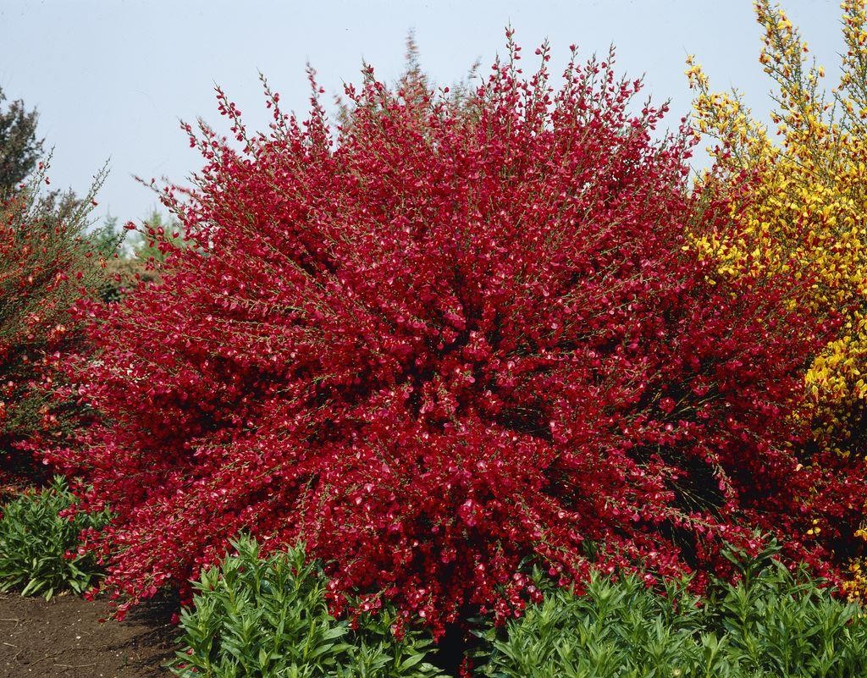

1 The small hole leads to a more open and open cavern tunnel, which has multiple similar crawlspaces as the one you crawled through, ultimately leading towards a junction. The caverns beyond this junction are lit up with lava, which make the caverns pretty visible. Left leads to a very lit lavalake and a pond of lava in a corner. Right leads to a longer stretch of cave, with lava visible on the other side.

2 On the other side of this lava lake you can see the cavern leading to multiple branches. This lava lake is about 10 feet wide. This might be a problem for certain characters.

3 The cave opens up behind a large pillar, where 3 firenewts can be seen keeping guard on the other side of the small metal bridge over the lava flows. If one of them notices the group, one of them will run away.

4 The corner leads to a large, thin tunnel, leading into darkness.

5 A locked metal door blocks this pathway. It is locked and can be lockpicked or bashed through (DC 14). Bashing against this door will alert the firenewts in the caverns, causing troubles for later. On the other side of this door are a couple of chests, with the following items: Damaged Wand of Magic Detection, a beautiful black gemstone with white bands (Onyx), and 3 gemstones with opaque bands of red and white (Sardonyx), as if depicting winds through the sand.

Damaged Wand of Magic Detection: This wand holds 1 charge, with it, you can cast Detect Magic. It crumbles to ashes afterwards.

6 The thin tunnel leads to a closed wooden door. It seems unlocked, but is blocked by something on the other side. Smashing it open (DC 10) makes a loud glass-shattering noise through the caverns, alerting the fire newts. If the door is opened with other means (let the creativity flow), it can be opened without the shattering noise. On the other side is a small cavernous hole, with its walls covered in a glass-like substance. Inside the cave is a Flail Snail (p144 Volo), which is slowly making its way towards the adventurers. If any is within 10 feet, it will use its Scintillating Shell ability. This Flail Snail has 75 HP.

If the Flail Snail dies by losing its tentacles and starts wailing, Fire newts will be interested, but not yet alerted. After x amount of time, a group of 3 fire newts will come to investigate. If the party leaves earlier, they will encounter them in the long tunnel. One will try to get away and alert the fire newts.

The glass-like substance on the cavern walls has shapes cut out of it, as if being harvested. In the opening of the door lie some gemstones: 2 Onyx and 2 Sardonyx gems.

7 The cave broads out here, showing a large lava flow to the right. 3 Fire newts, 1 on a Giant Strider keep guard here. The one of the giant strider will try to go away to alert the other fire newts.

8 A small bit of water, which is fairly warm leads to a small strip of cavern. This cavern has multiple exitways for steam to release into the caverns. Group members walking through this strip of cavern must make a DC14 Dexterity Saving Throw, or be blasted with 1d10 Fire Damage as steam is being released into the hallway.

9 This cavern is covered in more dirt than other parts of the cavern, and has little bits of funghi growing on the sides. A door is visible further up. This door is unlocked. If investigated (DC 10), the dirt is seemingly undisturbed, as if not used for a long time.

10 The wooden door is rotting, and seems to have not been in use for a long time. The other side shows a large open cave, with a high ceiling with some stalagtites. The ground shows some stalagmites, a small clear water pond, and funghi growing around it. If investigated (DC10), some bone residue can be found in the dirt here. A Roper resides in this cavern, surprising any poor bystanders. Only with investigation 18, can you prevent a surprised status.

11 The cavern leads somewhat downwards, and the temperatures are noticeably rising. Parts of the floor seem to be shining, as if coals being heated underneath your feet. Anyone without fire resistance wil gain the effects of one level of exhaustion while in this part of the cave, as it becomes harder to concentrate on anything.

12. The corner leads towards a large open cavern, with a large lava flow flowing throughout, and metal bridges crossing it. There are multiple Fire Newts and Giant Striders. If alerted, they will know about the coming of the peculiars, and can’t be surprised. If not surprised, they will not be in a defensive layout, on the other side of the bridges.

13 ?

14 The metal bridges seem somewhat unbalanced, and it is not wise to cross them all together. If 2 party members cross it in the same round, any following will have to do a dexterity saving throw to safely cross the bridge.

15 The cavern leads somewhat more upwards in a long stretch. Some lava flows light up the sides, but is otherwise unremarkable.

16 the temperatures in this part of the cavern is somewhat less than the previous part, but the humidity is remarkably higher. The same disadvantages as previous part of the cavern applies.   
The visibility in this cave is hindered by the steam. It’s still lighted by small flows of lava, but otherwise, the parties visibility is reduced to 30 feet. However, audible Fire Newt noises can be heard coming from further up. If the 5 fire newts were alerted, the party will be approached by them, and initiative will be rolled the moment they come within 30 feet.

17 This part of the cave contains 5 Fire Newts. Their visibility is also restricted, and will only see the group approaching the moment they come withing 30 feet. They make audible noises that can be heard from afar.